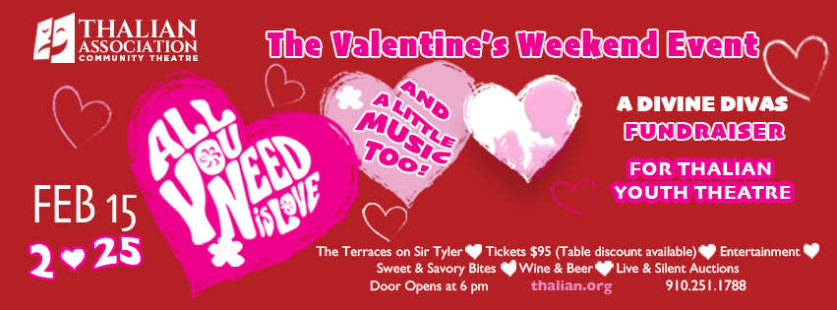
$3000 Sponsor Package Includes:
- Recognition in Event Night program
- 8 Tickets To “All You Need Is Love”
- Logo with link on website, social media recognition
- Company Logo on Stage Presentation Screen
- 20 Complimentary Tickets to TACT’s 2024-2025 Season
- Ads in Disney’s Mary Poppins and Legally Blonde programs

$1500 Sponsor Package Includes:
- Recognition in Event Night program
- 4 Tickets To “All You Need Is Love”
- Logo with link on website, social media recognition
- Company Logo on Stage Presentation Screen
- 10 Complimentary Tickets to TACT’s 2024-2025 Season
- Ads in Disney’s Mary Poppins and Legally Blonde programs

$750 Sponsor Package Includes:
- Recognition in Event Night program
- 2 Tickets To “All You Need Is Love”
- Logo with link on website, social media recognition
- Company Logo on Stage Presentation Screen
- 6 Complimentary Tickets to TACT’s 2024-2025 Season

$500 Sponsor Package Includes:
- Recognition in Event Night program
- 2 Tickets To “All You Need Is Love”
- Logo with link on website, social media recognition
- Company Logo on Stage Presentation Screen
- 2 Complimentary Tickets to TACT’s 2024-2025 Season

Susan Habas – Thalian Association Executive Director,
Joan Loch – Thalian Association Divine Divas Chairperson

Thalian Association Community Theatre • 120 S. 2nd Street • Wilmington, NC 28401
Divine Divas Presents are annual fundraisers to support Thalian Association Community Theatre and Youth Theatre productions and arts education outreach.

TACT supports the quality of life & economic vitality of the Cape Fear Region with theatrical productions at Thalian Hall, the 2nd Street Stage Historic USO Building, and other community venues, management of the Community Arts Center, the arts festival Orange Street ArtsFest, & Youth Theatre education/performance opportunities. Last year 76,546 people participated in Thalian Association productions, attended special events, or visited the Community Arts Center. 7006 youths & adults participated in youth theatre programs, 50,548 people attended an event or class at the Community Arts Center, and 18,992 people saw a show or special event.

Sponsorship Level:__________________________________________________

Company Name:____________________________________________________

Contact Person:____________________________________________________

Full Address:______________________________________________________

Phone:________________________________________Email:_______________________________________

Website:_________________________________________________________

Check Enclosed Visa MasterCard CC#___________________________________________________

Expiration Date___/___Sec. #______

Name as it Appears on Card____________________________________

Signature__________________________________________________________

Please make checks payable to Thalian Association with memo line Divine Divas event. Your event tickets will be reserved online and complimentary season tickets will be mailed to the address above. Email a high resolution logo shabas@thalian.org no later than 1/15.

Your potential tax deduction is based on the stated value for the sponsorship level choosen and this letter will serve as your receipt.
Our tax ID number is 56-0939043
Thank you for your generous support!

Established in 1788, Thalian Association Community Theatre is a non-profit, membership organization dedicated to enhancing the Cape Fear region through live community theatre and arts education. Thalian Association Community Theatre produces five major productions annually on the Main Stage at historic Thalian Hall and professionally manages the Hannah Block Historic USO/Community Arts Center for the City of Wilmington. The youth theatre program offers training and performance opportunities for children age seven through high school seniors. In 2007, Thalian Association Community Theatre was designated North Carolina’s Official Community Theater by the state legislature. For more information, visit www.thalian.org.

