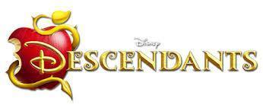**Disney’s Descendants the Musical**

**September 16-25, 2022**

**Fridays & Saturdays at 7:30 pm**

**Sundays at 3:00 pm**

**2nd Street Stage**

**Hannah Block Historic USO/Community Arts Center**

**120 South 2nd Street**

It is present-day, and in the kingdom of Auradon, all of Disney’s beloved heroes and royalty are living happily ever after, safe from the terrifying villains and troublesome sidekicks they have banished to the magic-free Isle of the Lost. That is until Ben, the benevolent teenage son of Belle and King Adam (The Beast), offers a chance of redemption for the troublemaking offspring of the evilest villains. Mal, Evie, Jay and Carlos – the children of Maleficent, the Evil Queen, Cruella De Vil, and Jafar – are welcomed to Auradon Prep to attend school with the children of their parents’ sworn enemies

**About the Thalian Association**

Thalian Association Community Theatre is a non-profit, membership organization that’s dedicated to enhancing the rich artistic environment of the Cape Fear region.  Tracing its roots back to 1788, the Thalian Association Community Theatre was founded to provide arts education and bring the excitement of the performing arts to Wilmington, North Carolina. Today the Thalian Association Community Theatre produces five major productions annually on the Main Stage at historic Thalian Hall, offers a Youth Theatre program and professionally manages the [Hannah Block Historic USO/Community Arts Center](http://www.wilmingtoncommunityarts.org/) for the City of Wilmington. In 2007, the North Carolina legislature named the Thalian Association Community Theatre the Official Community Theater of North Carolina.

**Language Activity: Character Name Word Search**

Disney’s Descendants the Musical has a ton of characters you might recognize from other Disney films! Circle the names of each character in the table below to complete the word search activity. Remember, names may be written horizontally, vertically, or diagonally!

|  |  |  |  |  |  |  |  |  |  |  |  |  |  |  |  |  |  |  |  |
| --- | --- | --- | --- | --- | --- | --- | --- | --- | --- | --- | --- | --- | --- | --- | --- | --- | --- | --- | --- |
| **M** | **A** | **L** | **E** | **F** | **I** | **C** | **E** | **N** | **T** | **X** | **N** | **F** | **G** | **B** | **J** | **O** | **P** | **E** | **W** |
| **W** | **P** | **Q** | **G** | **A** | **E** | **P** | **H** | **T** | **B** | **T** | **T** | **W** | **U** | **A** | **D** | **E** | **Q** | **V** | **S** |
| **A** | **S** | **E** | **V** | **I** | **S** | **Z** | **C** | **E** | **Y** | **Q** | **K** | **S** | **Q** | **X** | **S** | **Y** | **N** | **I** | **V** |
| **F** | **L** | **K** | **L** | **R** | **E** | **V** | **A** | **C** | **U** | **R** | **S** | **U** | **L** | **A** | **N** | **T** | **I** | **E** | **U** |
| **S** | **E** | **C** | **N** | **Y** | **S** | **T** | **P** | **D** | **L** | **A** | **G** | **D** | **F** | **W** | **R** | **Q** | **O** | **J** | **F** |
| **Y** | **E** | **I** | **B** | **G** | **D** | **W** | **T** | **Q** | **L** | **P** | **F** | **V** | **P** | **Q** | **D** | **I** | **B** | **N** | **I** |
| **U** | **P** | **K** | **D** | **O** | **E** | **V** | **A** | **U** | **J** | **U** | **F** | **G** | **C** | **B** | **S** | **Z** | **W** | **L** | **S** |
| **P** | **I** | **L** | **O** | **D** | **J** | **T** | **I** | **C** | **Z** | **N** | **Q** | **L** | **E** | **S** | **E** | **A** | **Z** | **H** | **N** |
| **T** | **N** | **W** | **I** | **M** | **A** | **T** | **N** | **D** | **Y** | **Z** | **U** | **Z** | **W** | **N** | **T** | **L** | **G** | **Q** | **O** |
| **H** | **G** | **A** | **T** | **O** | **F** | **Z** | **H** | **X** | **T** | **E** | **S** | **E** | **L** | **D** | **I** | **R** | **L** | **X** | **W** |
| **E** | **B** | **E** | **G** | **T** | **A** | **E** | **O** | **D** | **Q** | **L** | **C** | **Z** | **P** | **S** | **Y** | **E** | **N** | **E** | **W** |
| **B** | **E** | **O** | **S** | **H** | **R** | **P** | **O** | **H** | **R** | **D** | **W** | **A** | **O** | **D** | **P** | **V** | **D** | **Q** | **H** |
| **E** | **A** | **P** | **K** | **E** | **T** | **A** | **K** | **Z** | **E** | **V** | **I** | **L** | **Q** | **U** | **E** | **E** | **N** | **X** | **I** |
| **A** | **U** | **L** | **H** | **R** | **E** | **N** | **O** | **L** | **I** | **A** | **R** | **W** | **H** | **C** | **P** | **D** | **K** | **L** | **T** |
| **S** | **T** | **W** | **I** | **V** | **B** | **E** | **N** | **W** | **H** | **A** | **G** | **F** | **Q** | **V** | **H** | **E** | **Q** | **O** | **E** |
| **T** | **Y** | **T** | **R** | **E** | **O** | **E** | **W** | **Q** | **C** | **X** | **N** | **E** | **U** | **W** | **J** | **A** | **F** | **N** | **P** |
| **L** | **H** | **J** | **F** | **P** | **C** | **R** | **U** | **E** | **L** | **L** | **A** | **D** | **E** | **V** | **I** | **L** | **D** | **N** | **T** |
| **C** | **I** | **N** | **D** | **E** | **R** | **E** | **L** | **L** | **A** | **W** | **K** | **Y** | **F** | **P** | **A** | **J** | **E** | **I** | **V** |
| **H** | **L** | **K** | **J** | **A** | **Y** | **S** | **V** | **Q** | **D** | **F** | **Z** | **R** | **D** | **M** | **R** | **C** | **Z** | **E** | **K** |

**Mind Map Activity: Hero or Villain?**

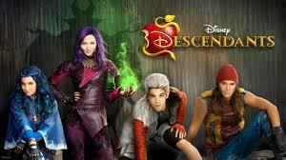The characters in Disney's Descendants the Musical are all heroes and villains from Disney stories. However, Descendants flips the idea of heroes versus villains around, making the villains the main characters.

In this activity you will discover what makes a character a hero or a villain. Think about the typical characteristics of each. What traits do heroes have? What about villains?

Using the template provided, you will create a Mind Map of hero and villain characteristics.

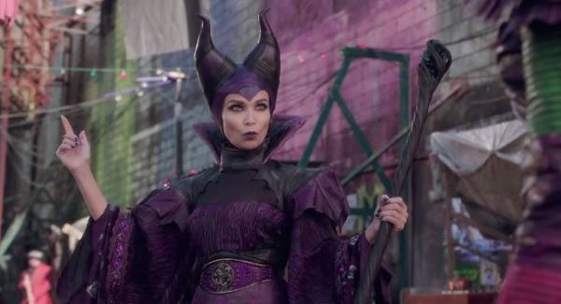**Step 1:** In the space below, write down traits, characteristics and ideas that describe heroes and/or villains.

**Step 2:** Using your answers from Step 1, write down words that represent heroes or villains. Circle each word and draw a line to connect it to the Hero bubble or the Villain bubble. If the word applies to both heroes and villains, connect it to both bubbles. For example, heroes are supposed to be selfless and villains are supposed to be selfish, but both have confidence.

**Hero**

**Villain**

Selfless

Confidence

Selfish

**Step 3:** After completing your Mind Map, discuss your results with your class or a partner. What do your Mind Maps have in common? How are they different? What common traits do heroes and villains have?

**Test Your Knowledge: Disney Character Quiz**

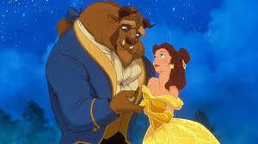You might recognize some of your favorite characters in Disney's Descendants the Musical! Take this quiz to discover how many Disney characters you already know!

1. Which Disney character fell in love with Belle in *Beauty and the Beast*?

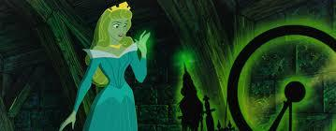2. Who was the sorcerer and Grand Vizier who advised the Sultan in *Aladdin?* (Hint: He was after the Genie's lamp!)

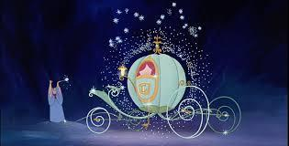3. In *Sleeping Beauty*, who tricks Princess Aurora into pricking her finger on a spinning wheel?

4. Which character transformed a pumpkin into a horse-drawn carriage for Cinderella?

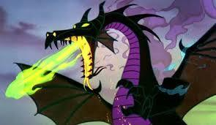5. Who asked questions to the Magic Mirror in *Snow White?*

6. Which character from *Sleeping Beauty* can transform into a dragon?

**Art Activity: Disney's Descendants Coloring Sheet**

