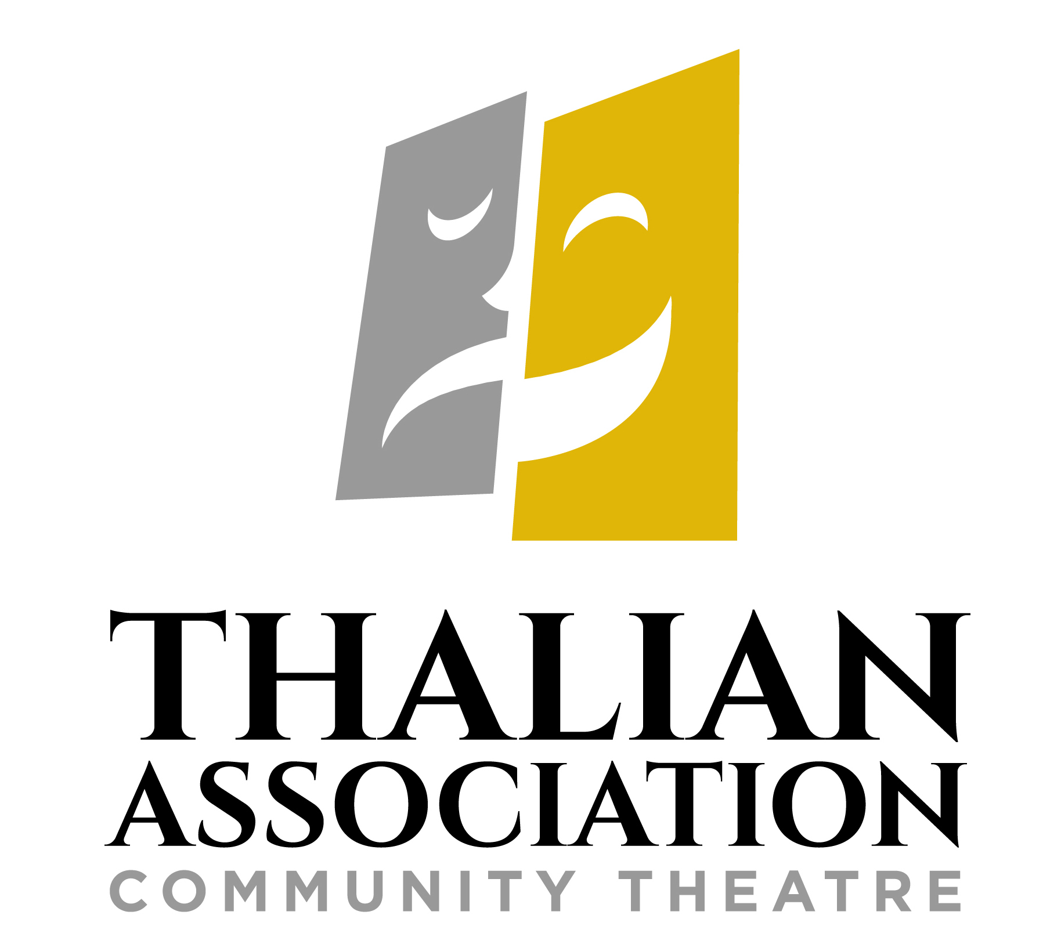

FOR IMMEDIATE RELEASE

CONTACT:

Susan Habas, Executive Director  
Thalian Association Community Theatre  
910-251-1788 [shabas@thalian.org](mailto:shabas@thalian.org)

**Thalian Association Fundraiser Show Me a Show Tune Goes Live!**

**Vote for Your Favorite Video & Support Community Theatre**

Wilmington, NC - Are you a fan of Broadway musicals? Would you like to watch your friends sing your favorite show tunes online? Now you can watch local music videos and vote for your favorites by donating to Thalian Association Community Theatre. Show me a Show Tune is a new Facebook fundraiser to support Thalian Association’s productions, Youth Theatre programs, and arts education.

Show Me a Show Tune will be live on Facebook at Show Me a Show Tune Sept. 16th – Oct. 7th. Thirty-six contestants submitted diverse videos representing all categories of Broadway musicals from classic Rodgers and Hammerstein to Lin-Manuel Miranda. Anyone can vote for their favorite videos by contributing to Thalian Association using the Facebook donate button. Contestants are encouraged to make their videos during this time go viral by sharing via social media and encouraging friends and family to show support by voting with a minimum donation of $1. The top 3 fundraising videos will be the winners!  They will receive a trophy designed by Kids Making It and have their videos hosted permanently on the Thalian You Tube channel.

“I can’t believe the fabulous & innovative videos we received from people of all ages,” said Susan Habas, Executive Director of Thalian Association Community Theatre. “This amazing show of local talent is the reason community theatre in the Port City is so good. I hope everyone will vote to support the talent and enthusiasm of our participants and to make sure Thalian Association is ready with new productions when theatres open!”

“These incredible videos demonstrate how important the performing arts are to our community,” said Thalian Association Board Member and Fundraiser Chair-Person Star Sosa. “I’m grateful that Show Me a Show Tune attracted so many lovely entries and hope it will result in much needed fundraising for Thalian Association. Soon our community will be together again to celebrate our love of theatre, performance, and music.”

Established in 1788, Thalian Association Community Theatre is a non-profit, membership organization dedicated to enhancing the Cape Fear region through live community theatre and arts education. Thalian Association Community Theatre produces five major productions annually on the Main Stage at historic Thalian Hall and professionally manages the Hannah Block Historic USO/Community Arts Center for the City of Wilmington. The youth theatre program offers training and performance opportunities for children age seven through high school seniors. In 2007, Thalian Association Community Theatre was designated North Carolina’s Official Community Theater by the state legislature. For more information, go to [www.thalian.org.](http://www.thalian.org./)

