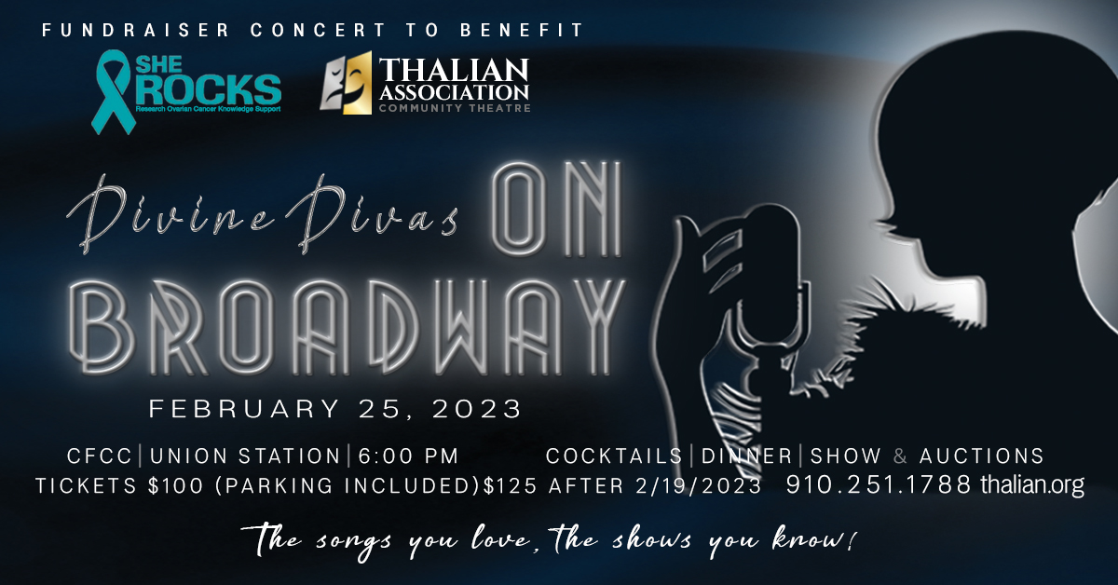

$3000 Sponsor Package Includes:
- Recognition in Event Night program
- 8 Tickets To “On Broadway”
- Logo with link on website, social media recognition
- Company Logo on Stage Presentation Screen
- 20 Complimentary Tickets to TACT’s 2022-2023 Season
- Ads in Rodgers & Hammerstein’s Cinderella & The Wedding Singer programs

$1500 Sponsor Package Includes:
- Recognition in Event Night program
- 4 Tickets To “On Broadway”
- Logo with link on website, social media recognition
- Company Logo on Stage Presentation Screen
- 10 Complimentary Tickets to TACT’s 2022-2023 Season
- Ads in Rodgers & Hammerstein’s Cinderella & The Wedding Singer programs

$750 Sponsor Package Includes:
- Recognition in Event Night program
- 2 Tickets To “On Broadway”
- Logo with link on website, social media recognition
- Company Logo on Stage Presentation Screen
- 6 Complimentary Tickets to TACT’s 2022-2023 Season

$500 Sponsor Package Includes:
- Recognition in Event Night program
- 2 Tickets To “On Broadway”
- Logo with link on website, social media recognition
- Company Logo on Stage Presentation Screen
- 2 Complimentary Tickets to TACT’s 2022-2023 Season

Susan Habas – Thalian Association Executive Director, Joan Loch – Thalian Association Divine Divas Chairperson

Thalian Association Community Theatre • 120 S. 2nd Street • Wilmington, NC 28401
Divine Divas Presents are annual fundraisers to support Thalian Youth Theatre and She ROCKS (Resercah Ovarian Cancer Knowledge Support). Since 2017 Thalian Association through Divine Divas has donated $34,227.65 to She ROCKS.
Sponsorship Level:__________________________________________________

Company Name:____________________________________________________

Contact Person:____________________________________________________

Full Address:______________________________________________________

Phone:________________________________________Email:_______________________________________

Website:_________________________________________________________

Check Enclosed Visa MasterCard CC#___________________________________________________

Expiration Date___/___Sec. #______

Name as it Appears on Card____________________________________

Signature__________________________________________________________

Please make checks payable to Thalian Association with memo line Divine Divas event. Your event tickets will be reserved online and complimentary season tickets will be mailed to the address above. Email a high resolution logo shabas@thalian.org no later than 1/15.

Your potential tax deduction is based on the stated value for the sponsorship level choosen and this letter will serve as your receipt.
Our tax ID number is 56-0939043
Thank you for your generous support!

She ROCKS, Inc. was formed in May 2014 with the intention to raise funds for ovarian cancer research and to provide knowledge and local support to those affected by all types of cancer. She ROCKS began in Wilmington, and has expanded to include She ROCKS The Triad, serving Greensboro, High Point and Winston-Salem. Since its inception, She ROCKS has raised more than one million dollars. The organization gives seventy-five percent of the funds to UNC Lineberger Comprehensive Cancer Center to fund ovarian cancer research, and twenty-five percent to NHRMC Zimmer Cancer Center to purchase support items, such as new chemo chairs for the infusion suite, gas cards, wigs, and numerous other comfort and care items.

Established in 1788, Thalian Association Community Theatre is a non-profit, membership organization dedicated to enhancing the Cape Fear region through live community theatre and arts education. Thalian Association Community Theatre produces five major productions annually on the Main Stage at historic Thalian Hall and professionally manages the Hannah Block Historic USO/Community Arts Center for the City of Wilmington. The youth theatre program offers training and performance opportunities for children age seven through high school seniors. In 2007, Thalian Association Community Theatre was designated North Carolina’s Official Community Theater by the state legislature. For more information, visit www.thalian.org.

