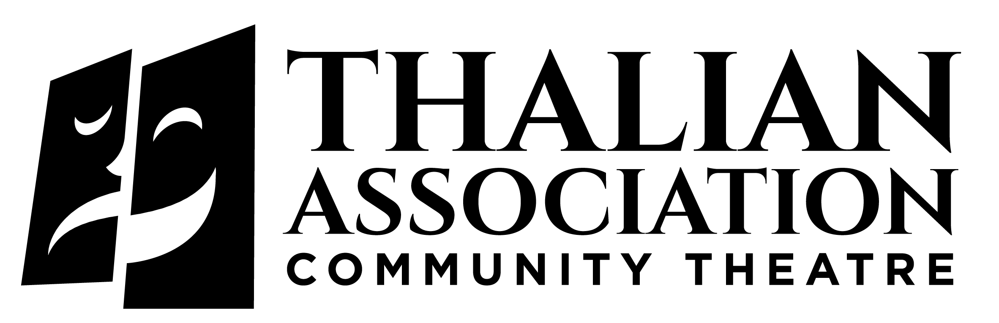

The Official Community Theater of North Carolina
Box 1111 • Wilmington, NC 28402 • 910.251.1788 • www.thalian.org

2023-2024 Community Theatre Season
- Five productions at Historic Thalian Hall
- Five Youth Theatre productions at the HBHUSO/CAC

Must See Theatre for the Whole Family!

2023-2024 SEASON TICKET PACKAGES AND BENEFITS

ALL PASSES INCLUDE:
- Name recognition in all 2023-2024 Community Theatre programs
- Priority Seating or Will Call option at Thalian Hall
- Invitation to the Awards Ceremony July 2024
- Vote for your favorite shows & performers
- No sales tax & handling fees

Community Theatre Flex Pass $175.00
Five tickets for Thalian Hall productions. Tickets can be used for any performance of your choice.

Patron Flex Pass $440.00
Ten tickets for Thalian Hall productions. Tickets can be used for any performance of your choice. $100.00 of your cost is donated to support Thalian Youth Theatre programs.

Community Theatre & Youth Theatre Flex Pass $250.00
Five tickets for Thalian Hall productions plus five tickets for Youth Theatre productions on the Second Street Stage in the HBHUSO/Community Arts Center. Youth Theatre tickets will be on the Will Call list at the Community Arts Center - the Second Street Stage is a general admission venue with seating in a first-come basis.

Become a Voting Member $150.00
Add $150.00 to any flex pass package to become a voting member of Thalian Association Community Theatre and attend the Annual Meeting.

*Thalian Association pays 7% NC & NHC sales tax per ticket and any applicable venue preservation & handling fees for all season ticket packages.

Base ticket price for Thalian Hall $34.00 and Youth Theatre productions at the HBHUSO/CAC $14.00

Name as you wish to appear in program
Address
City State Zip Day Phone
Eve Phone E-mail
For priority assigned seating for our five Thalian Hall productions, please select the performances you wish to attend and your seat preference in the box below:
Seat Preference for all selected performances _________________________________________
A Chorus Line | Fri 9/29 @ 7:30pm | Sat 9/30 @ 7:30pm | Sun 10/1 @ 2pm
 | Fri 10/6 @ 7:30pm | Sat 10/7 @ 7:30pm | Sun 10/8@ 2pm
Elf the Musical | Thurs12/7@7:30pm | Fri 12/8 @ 7:30pm | Sat 12/9@7:30pm
 | Sun 12/10@2:00 pm  Sat 12/16 2:00pm | Thurs12/14@7:30pm  Sat 12/16 @ 7:30pm | Fri12/15@7:30pm Sun 12/16 2:00pm
Steel Magnolias | Fri 2/9 @ 7:30pm | Sat 2/10 @ 7:30pm | Sun 2/11 @ 2pm
 | Fri 2/16 @ 7:30pm | Sat 2/17 @ 7:30pm | Sun 2/18 @ 2pm
Disney Beauty & the Beast | Fri 4/5 @ 7:30pm | Sat 4/6 @ 7:30pm | Sun 4/7 @ 2pm
 | Fri 4/12 @7:30 pm | Sat 4/13 @ 2:00 pm  Sat 4/13 @ 7:30 pm | Sun 4/14 @ 2pm
The SpongeBob Musical | Fri 5/17 @ 7:30pm | Sat 5/18 @ 7:30pm | Sun 5/19 @ 2pm
 | Fri 5/24 @ 7:30pm | Sat 5/25 @ 7:30pm | Sun 5/26 @2 pm

Membership/Sponsorship Package  (Please check one option) | Ticket Delivery Method  (Please check one option)
Main Stage Flex Pass @ $175  Patron @ $440  Main Stage/Youth Flex Pass @ $250  Voting Member @ $150.00  Benefactor @ $1200  Director’s Circle @ $2,750  Producer’s Circle @ $5000  Executive Producer @ $10,000 | I prefer to be on the Thalian Hall Will Call list at the box office & make my reservations for each production.  I have indicated the Main Stage Thalian Hall performances I wish to attend above with date and seat preference  Please Note:  *Youth Theatre performances are at the HBHUSO/CAC – a general admission venue. Reserve seats on a per show basis at 910.341.7860 or 910.251.1788.
Ticket Package/Sponsorship Amount x Quantity  Optional Membership  Please accept my tax-deductible contribution  Handling/Admin Fee  TOTAL PAYMENT | $_____________ x _____ = ___________________  $________________________  $________________________  $_________4.00___________  $_______________________

Check Enclosed Visa MasterCard CC#___________________________________________________
Expiration Date___/___Sec. #______ Name as it Appears on Card____________________________________
Signature__________________________________________________________________________________

Please return by August 18, 2023 to lock in preferred seating.
Thalian Association Community Theatre • 120 S. 2nd Street • Wilmington, NC 28401

